|  |  |
| --- | --- |
|  |  |
|  |
|  |

**Project Report**

**Computer Vision Module Project**

**Name: Mureed Hussain Droty**

**Gmail: drotynew3492@gmail.com**

**Roll No: sk23102**

**Campus: Nust skardu**

**Course : Artificial intelligence and data science**

**Instructor: Mr. Sajid**

**Project Title:** Expression Classification from Facial Images

**Objectives:**

* Understand the fundamentals of using a deep ConvNet
* Learn how to use Tensorflow/Keras
* Learn how to use Google Colab
* Learn how to train (fine-tune) a convolutional neural network architecture

**Summary:**

In this project I work on face emotion recognition using **fer2013 dataset. I**n this project I tried to predict the emotion of a person. First of all I mounted google drive to colab and after that we make a file name as facial expression on google drive and in this folder we drop our database after that in google colab we use the directory to access the dataset.

The dataset selected for our project is fer2013 dataset. We choose this dataset because it is specific for facial emotion expression and also it has seven classes of face expression.

The **Fer2013** dataset is for facial expression recognition and contains faces manually labeled with expressions (Figure 1). Each of the face images is annotated as one of the seven basic expression categories: “angry (0)”, “disgust (1)”, “fear (2)”, “happy (3)”, “sad (4)”, “surprise (5)”, or “neutral (6)”.

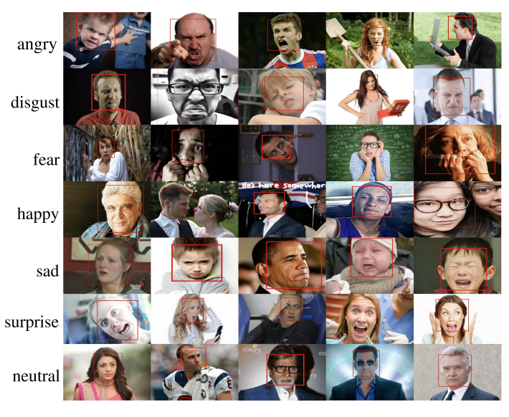

Figure 1: Sample Images from ExpW Dataset

**Project Details**

**The project is divided into several stages:**

**Training: I**  Split the data into Training/Validation/Test. Using deep learning framework such as Keras or TensorFlow to train a Convolutional Neural Network on the annotated dataset.

**Testing:** The model is tested on a separate test set of images that was not used for training.

**Evaluation:** we check the performance of the model by measuring its accuracy matric.Also plot a confusion matrix to determine which expression class is predicted correctly and which is challenging for model.

This is my project detail I fond some exception on it but we can improve it by using data cleaning and usage of more epochs.

By doing this project I also familiar with colab,keras, tensorflow etc

Best of luck